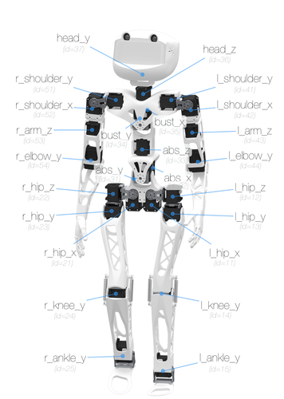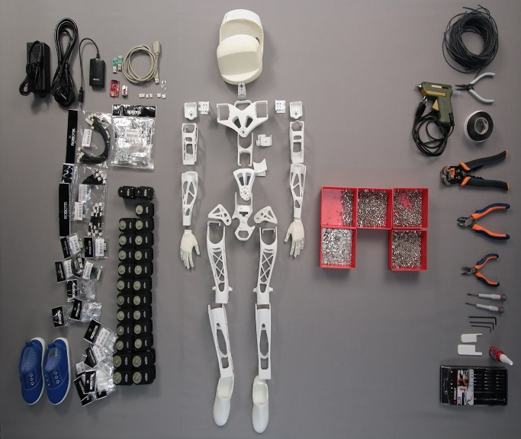

This task is about how to make the decision for choosing our motor in Poppy Robot joint between the links. We have two options there are:

1. 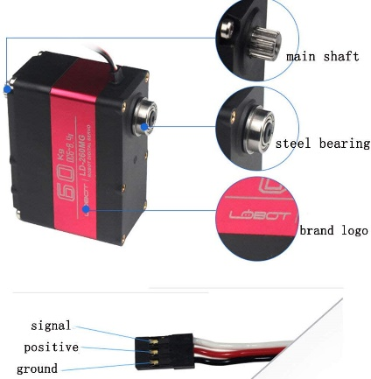LOBOT LD-260MG

**Description:**

Brand: LOBOT

Product: LD-260MG Digital Servo

Working Voltage: 6.0-8.4V

No-load Speed: 0.17sec/60°(6.0V), 0.15sec/60°(7.4V), 0.13sec/60°(8.4V)

Stall Torque: 58kg.cm(6.0V), 65kg.cm(7.4V), 70kg.cm(8.4V)

Anti-block Current: 3.5A(6.0V), 5A(7.4V), 6.2A(8.4V)

Rotation: 180°

Wire Length: 30CM

Gear: Metal

Product Weight: About 163g

Product Size: 65*30*48mm

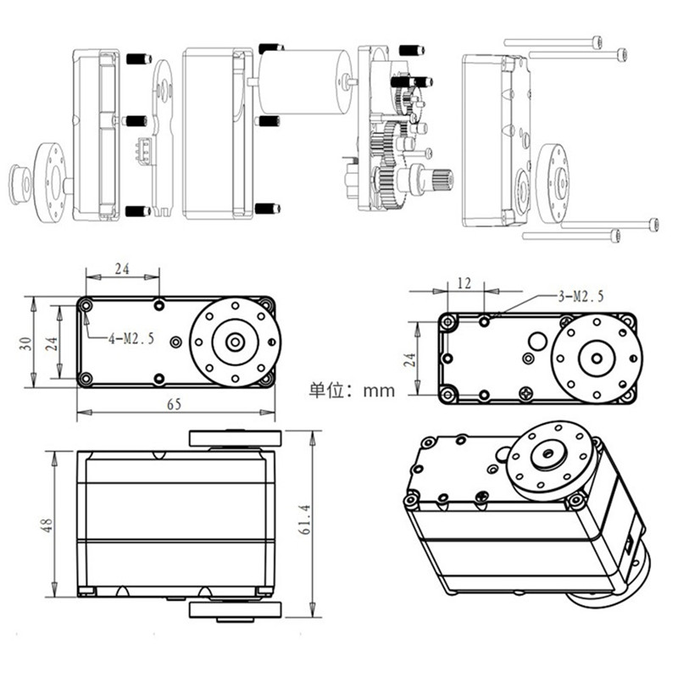Application: For RC Robot,RC Car

1. **MG995**

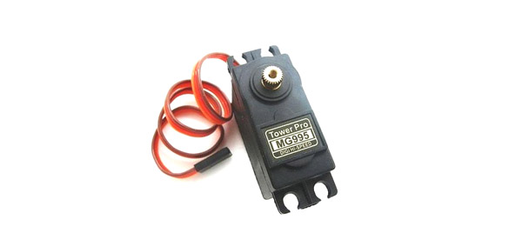**Description:**

Get your start in robotics and making things move! The MG995 is an excellent choice for a high torque, digital metal geared servo. It comes in a standard size and its metal gears mean when the motor is in a jam, the gears aren’t likely to strip.

This medium servo will rotate up to 60 degrees. This servo with its metal gears comes in at 55g and is a good choice for medium-large sized projects.

Each servo comes with 3 arms and screws and with pre-soldered female wires. When using servos, we recommend using pin 9 or 10, a standard in the Servo library.

Metal geared servo for more life

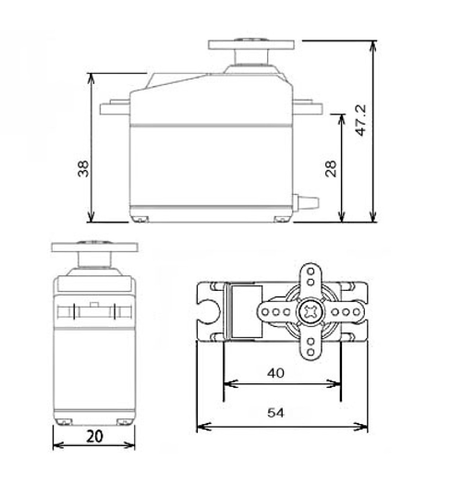Stable and shock proof double ball bearing design

High speed rotation for quick response

Fast control response

Constant torque throughout the servo travel range

Excellent holding power

Weight: 55 g

Dimension: 40.7×19.7×42.9mm

Operating voltage range: 4.8 V to 7.2 V

Stall torque: 9.4kg/cm (4.8v); 11kg/cm (6v)

Operating speed: 0.2 s/60º (4.8 V), 0.16 s/60º (6 V)

Rotational degree: 180º

Dead band width: 5 μs

Operating temperature range: 0ºC to +55ºC

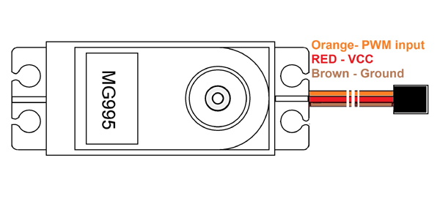Current draw at idle: 10mA

No load operating current draw: 170mA

Current at maximum load: 1200mA

To select the motor there are several characteristics that we need to pay attention to for example, voltage, current, torque, velocity and the price!

**Torque:**

You should always look at the required operating torque, but some applications will require you to know how far you can push the motor. For example, with a wheeled robot, good torque equals good acceleration, but you must make sure the stall torque is strong enough to lift the weight of the robot. In this instance, torque is more important than speed. In our situation it can be seen that 260MG has higher Torque and can carry almost 58 kg. However, the opposite is true for the other motor.

**Voltage:**

As we know the higher the voltage, the higher the torque. Be sure to apply the recommended voltage. If we apply too few volts, the motor will not work. Based on the information above, the range is almost similar, but it is higher in 260MG with 8.4 V.

**Weight:**

In our Robot we seek to use a lightweight motor which will help us move the link easily and in more efficient way. MG995 is lighter than the other which has 136 g. The different is significant!

**Price:**

Money is a critical factor in our decision and as it is shown above MG995 is cheaper than 260MG.

To sum up, for our purpose I think 260MG is the perfect one as it has a high torque and can carry 58kg, so the links are able to carry heavy weights and move perfectly.

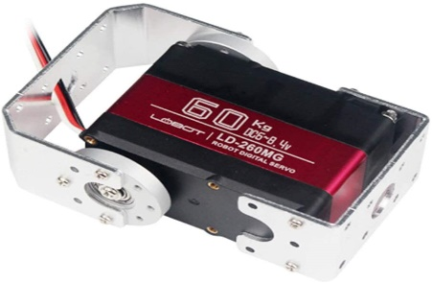

**References:**

* <https://www.smart-prototyping.com/Servo-Motor-M-Metal-Gear-MG995>
* <https://www.teknistore.com/en/rc-helicopter-parts/52333-lobot-ld-260mg-180-60kg-largetorque-metal-gear-digital-servo-for-rc-robot.html?mobile_theme_ok>
* <https://phi-education.com/store/servo-motor-MG995>
* <https://www.aliexpress.com/item/33054590443.html>
* <https://www.jameco.com/Jameco/workshop/ProductNews/motor-buyers-guide.html>